Microsoft Teams Guide for logging in as a guest user

Once you have been added by the event manager, Ida, to the Team for the Energy & Transport Summit IV digital you will receive the following email:

By clicking “Open Microsoft Teams” you will be taken to a website which will allow you to launch the MS Teams App if you already have it downloaded. If you don’t have the app, you can opt to “Use the web instead” and log in from there.

If you make it to the following page on the MS app, please open the drop-down “Select a Teams org” and choose “Wind Logistics Group (guest)”:

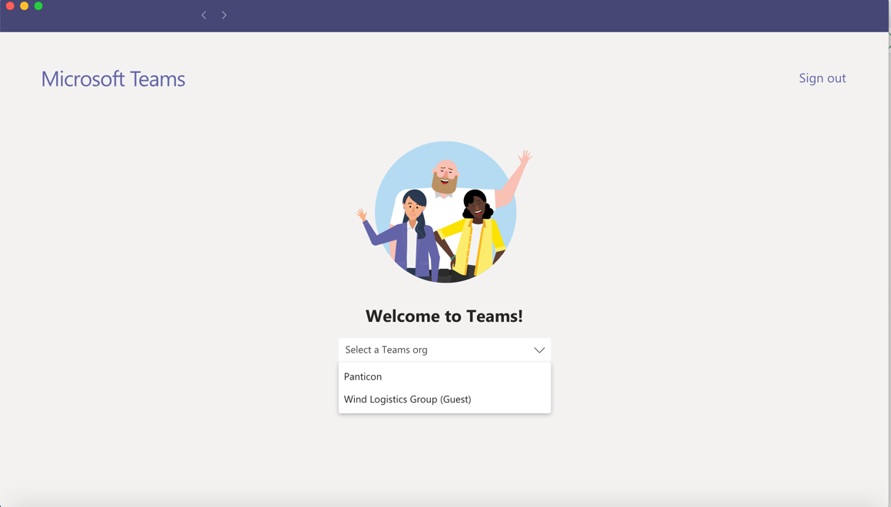

You will then be prompted to log in again with your usual log in details. MS might ask you to go through extra steps to protect your account (a recent addition to their security measures). You can go through these steps or opt to “Skip for 14 days until this is required”. Once logged in, you should be able to access the Teams as usual.

If you are having difficulties accessing the Teams, please log out and kindly log in again – the option to choose the organisation in the drop-down should then appear.

You may experience a loop which could be challenging to resolve and here are the three most common ways to fix such an issue:

- NB: If you are registered with MS Teams already using a different email than the one you have received an invitation to join from, this can cause issues. If that is the case, please contact eventmanager@energytransportsummit.com and kindly provide the email you are normally registered with in MS Teams. We will then add to the Energy Transport Summit IV digital Team using that alternate email instead. You will then receive an invitation to that email instead.

- NB: If you are registered with multiple emails to MS Teams, this can also cause issues. Please make sure you are logged into the account that you have used to obtain the invite to join the Team – MS Teams might ask you to prove your identity and this may cause you to enter into a loop that is hard to exit. If this happens, we recommend that you please use the web-version of MS Teams instead of the desktop app when prompted during the log-in procedure.

- NB: If you are not registered at all to MS Teams, please go to the following website to register with the email you used to get your invite from: https://www.microsoft.com/en-us/microsoft-365/microsoft-teams/group-chat-software?rtc=1

If any issues persist or other challenges occur, please contact Ida by email at eventmanager@energytransportsummit.com

